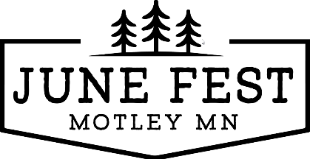

**7th Annual June Fest 4 mile and 1-mile walk/run**

**When: Saturday June 14, 2025**

**Register/Start & Finish line: Converse Park**

281 Beaulieu St W Motley

**Same day registration at 7:45 am**

**Pre-registered at 8:00am**

**National Anthem: 8:25am**

**4 mile starts at 8:30 am**

**1 mile starts at 9:15am**

**Cost: 1 mile $15; 4 mile $25**

**(Please register by May 16th to guarantee t-shirt)**

100% of the proceeds are used for June Fest activities

**Price includes:**

* T-shirt (guarantee for all pre-registered racers)
* Drawstring backpack
* Snacks after the race
* Free beverage after race
* 4 mile prize for fastest male and female
* All 1 mile finishers will be in a drawing for prizes

**Register below or online at:** [**https://www.eventbrite.com/e/1253483425669?aff=oddtdtcreator**](https://www.eventbrite.com/e/1253483425669?aff=oddtdtcreator)

**Or send in the below form**

**---------------------------------------------------------------------------------------------------------------------------------------------------**

**Registration information: ____1 mile _____4 mile**

**Name(s):____________________________________________________________________**

**Age(s):_________ *\*Anyone under 5 needs an adult to walk/run w/ them.***

**Adult Contact name:_________________________________________**

**Adult contact phone #______________________________________**

**Total $ _______**

**Make checks payable to: MCEO and mail to: June Fest PO Box 562 Motley MN 56466

**T-Shirt size (circle one): Youth: YXS, YS, YM, YLG Adult: S, M, L, XL, 2XL, Other __**

**Any questions or interest in volunteering please contact:**

[**Motleyjunefest@gmail.com**](mailto:Motleyjunefest@gmail.com) **or Amy Brichacek @** [**amybrichacek@gmail.com**](mailto:amybrichacek@gmail.com) **612-910-6595**